SCHEDULE

HOURS

Design and Testing 2

Table of Contents

Introduction 2

Schedule breakdown 3

Cost estimate table 3

Time for each issue 4

# Introduction

In the following document we will proceed to detail the work of each member of team 6 in a schedule breakdown. This decomposition has been provided by the Toggle application. Once the total number of working hours of each member is obtained, each of them is counted. Today a software engineer whose experience based on D&T1 has been outstanding, as in the case of this team, would receive around € 15-16 per hour. It will be established that each member of the team receives € 8 per hour, excluding taxes and other expenses. Next, there will be a report of the team, whose names are: Ángel Delgado Luna, Belén Garrido López, María de Gracia Piñero Pastor, Ezequiel Portillo Jurado and Alejandro Rodríguez Díaz.

# Schedule breakdown

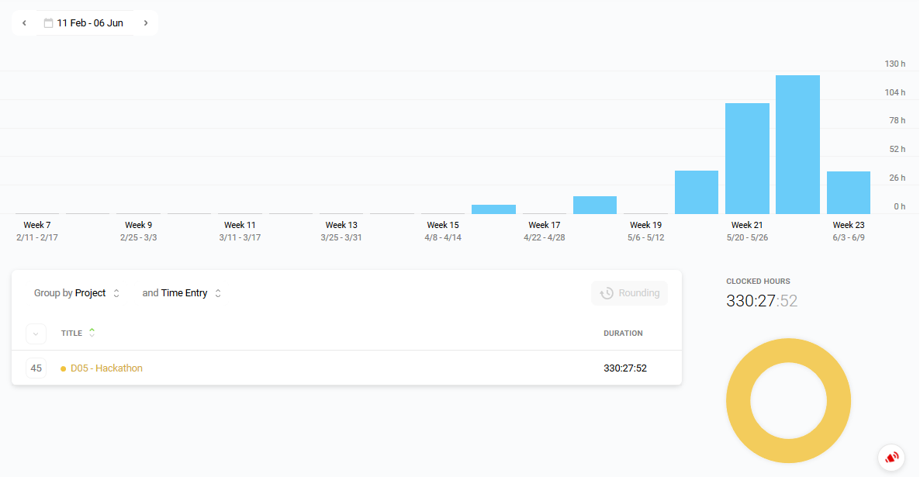The members have been working a sum of 149 hours 12 minutes, which is equivalent to a payment for his part of € 2.238,75.

## Cost estimate table

|  |  |  |  |  |
| --- | --- | --- | --- | --- |
|  | *Hours employed* | *Minutes employed* | *Overall time* | *Entire cost* |
| Cost per hour: 15€ | 330 |  |  |  |
| Cost per 30 minutes: 8,50€ |  | 27 |  |  |
| Cost per 15 minutes: 4,25€ |  |  |  |  |
| Final payment: |  |  | 330:27 | 4958.5 |

### Initial cost

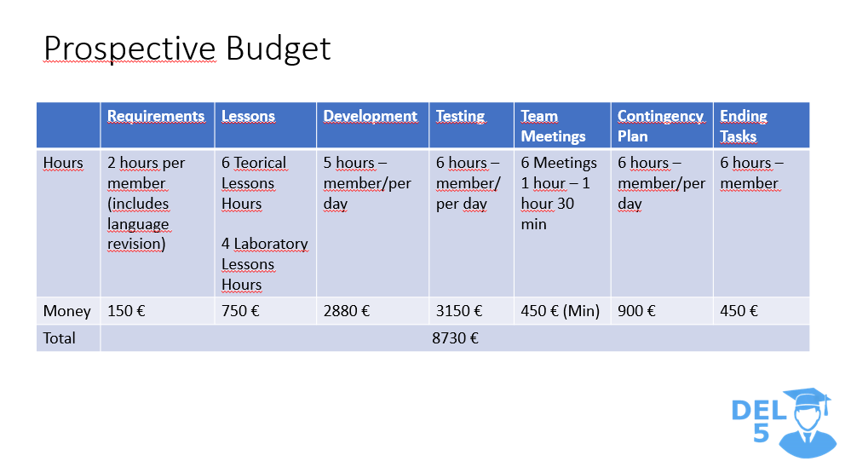

### Time for each issue

Attached in the same folder as this document.